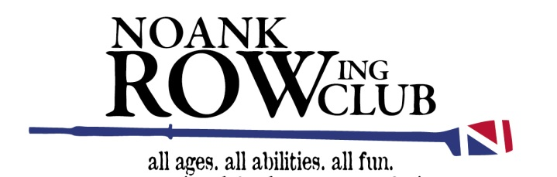

A Bit About Weather

Our first priority is safety.

Spring Summer & Fall
While on the water, we can easily be caught in harm’s way.

With this in mind, NRC Group Rowing and NRC on-the-water rowing classes will be canceled if heavy rain or thunderstorms are in our area:

- Rowing Classes will be held in the old boathouse, instead of the water.
- NRC Group Rowing will meet to row on the next opportunity.

Winter Conditioning
While in Winter Conditioning on Fitch HS campus, snow is a reason school systems cancel classes. With this in mind, NRC Winter Conditioning Class will be canceled when Fitch HS classes are cancelled. If you have a question on a particular day, go to our website to see if Winter Conditioning Class is canceled as notified on the home page.

In the Spirit of Rowing –

The coaches of NRC

